Dashboard Manual
This manual describes how to navigate and interact with the Europe vs. Middle East financial-development dashboard in Tableau. It covers filtering, drill-downs, and tooltip functions, illustrating each feature with examples.
1. Applying the Year Filter
At the right edge of the dashboard is a vertical slider labelled “Year” showing the range 2011–2022. Click and drag the blue handles to select a single year or a range. For example, to view data for 2020 only, drag both handles to “2020” and release. All visuals—the KPI cards, map, and line charts—will update instantly to reflect that year’s data.
Screenshot 1: Year slider set to 2020
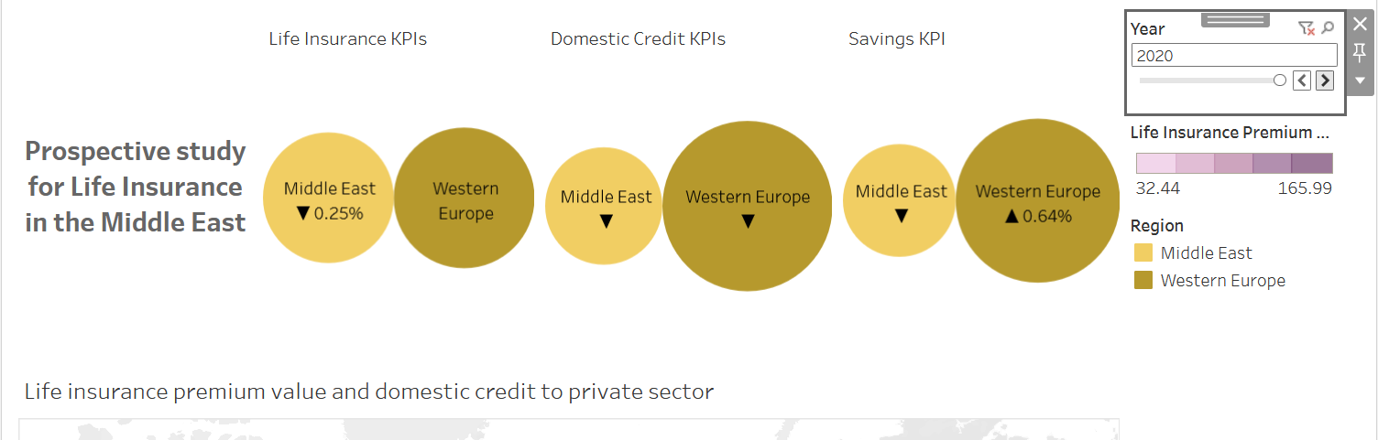
2. Toggling Region Visibility
Next to each line chart (“Savings behavior,” “Credit availability,” and “Insurance premiums”) you’ll find color legend buttons labeled “Europe” and “Middle East.” Click a button to hide or show its region’s line. Hidden regions turn gray, and their data points disappear, allowing you to focus on the other region. For instance, click “Europe” to compare only Middle East trends over time.
Screenshot 2: Middle East line highlighted, Europe hidden
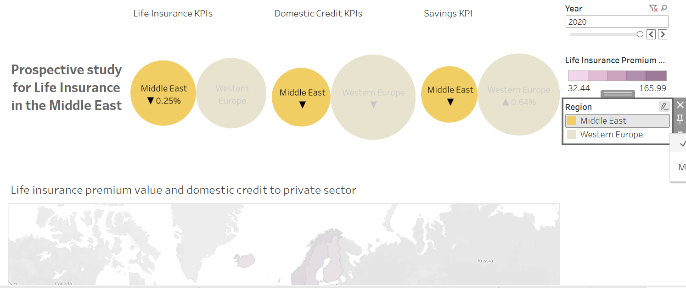
3. Reading KPI Cards
At the top are three large cards showing the selected-year totals for savings rate, credit-to-GDP, and premium-to-GDP. Hover your mouse over each card to see the exact numeric value in a tooltip. For example, hovering over the “Saved at a financial institution” card for 2020 displays “Europe: 58.3%; Middle East: 46.7%.” These cards give you an at-a-glance comparison.
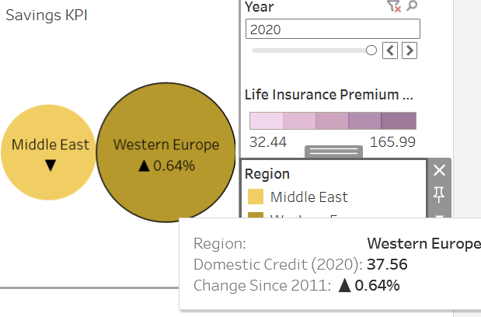
Screenshot 3: Hover tooltip on KPI card
4. Exploring Country‐Level Details on the Map
The central pane is a choropleth map with proportional circles. Colours represent premium-to-GDP intensity. To inspect a country, move your cursor over it; a tooltip appears showing that country’s exact values for both metrics in the selected year.
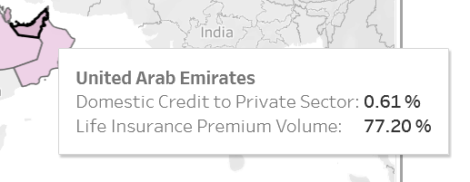
Screenshot 4: Tooltip sidebar for UAE

5. Analyzing Temporal Trends with Line Charts
Below the map, three line charts plot Europe vs. Middle East over time. Each chart has markers at every year. Hover over a marker to see the precise value in a small tooltip. To drill down, click a marker; the same detailed sidebar tooltip (as in the map) appears, showing a country-level bar-chart breakdown for that year.
Screenshot 5: Clicked marker on credit trend line
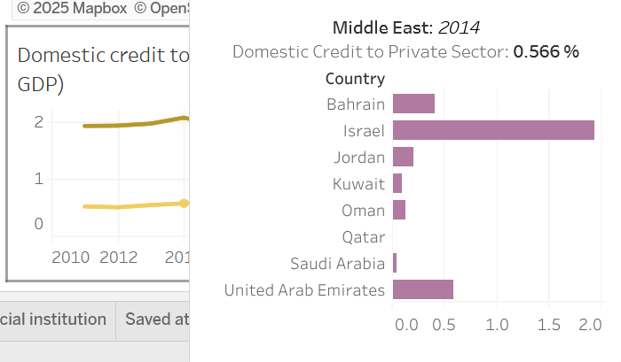
6. Example Workflow
Suppose you want to explore why the UAE shows high credit but low insurance uptake in 2020. First, set the Year slider to 2020. Next, hover over the map’s UAE circle to confirm its credit and premium values. Then click that circle to open the sidebar tooltip, where horizontal bars rank UAE against other Middle East countries. Finally, toggle between “Europe” and “Middle East” in the legends to isolate regional patterns.

7. Tips for Effective Use
– Use the Year slider before drilling down to avoid confusion from stale filters.
– Combine region toggles with drill-downs to compare specific countries across regions.
– Hover over all visuals to access exact numbers without clicking.
– Refresh the dashboard if performance lags after multiple filter changes (Tableau’s circular refresh button at top right).

